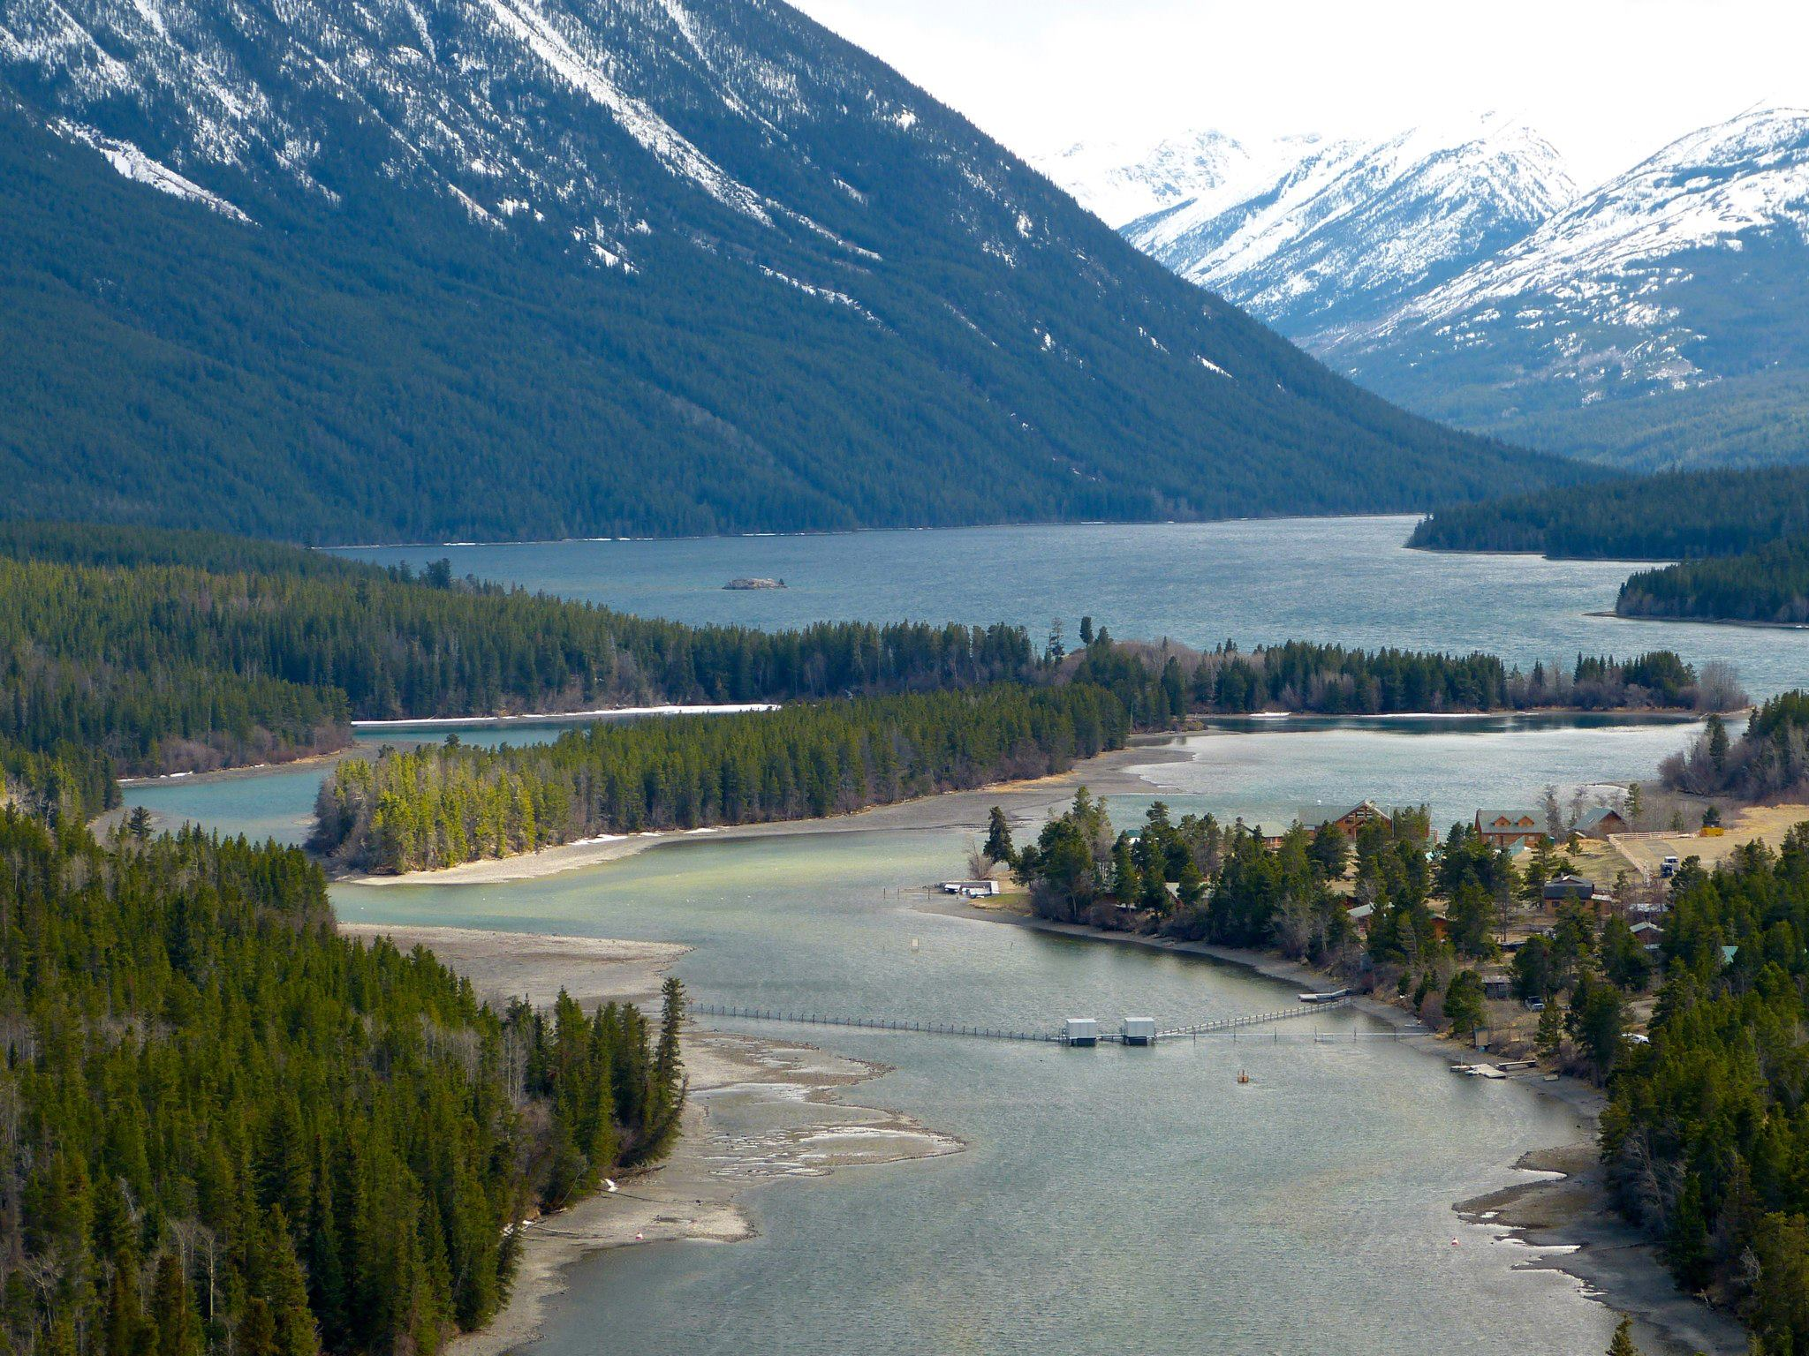
Fig. S1. Counting fence configuration deployed by the Fisheries and Oceans Canada, located in Chilko Lake (Tŝilhqox Biny, traditional territory of the Xeni Gwet’in First Nations, one of the six communities forming the Tŝilhqot’in Nation), British Columbia, Canada. The counting fence is used to estimate densities of outmigrant smolts and is closed when no smolts are present. Photo by Marika Gale.

Fig S2. Empirical cumulative distribution function of presumed Bull Trout lengths (cm) measured for every record interaction. The blue-line is smoothed for visualization purposes. Black dashed-lines represent the minimum (41.5 cm) and maximum (79.5 cm) lengths of Bull Trout observed in Kanigan 2019, which were sampled via hook-and-line and dip netting for telemetry studies.

